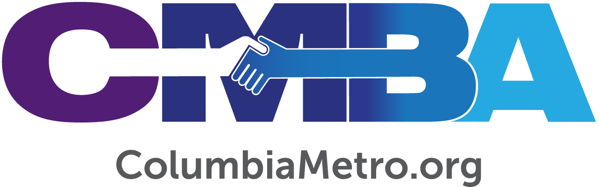

Vision Plus Intentionality is the Holy Grail

By
George W. Bullard, Jr., Director
Columbia Metro Baptist Association
GeorgeBullard@ColumbiaMetro.org

Vision Plus Intentionality are the three most important words in congregational vitality and vibrancy. Yet, because they are not poetic words pulsating on your screen or highlighted on your paper, the depth of their meaning and significance may allude you.

Recall the search for the Holy Grail as depicted in the movie Indiana Jones and the Last Crusade. When a he and others discovered a display of various cups that could be the one used by Jesus and His disciples at the Last Supper, at first one person assumed the most ornate cup to be the correct cup. It was not. Indiana Jones realized it must be the common cup of a carpenter, and he was right.

The Holy Grail of congregational vitality and vibrancy is not in poetic form, but in declarative words that speak simple truths. As a result, many congregations miss the Holy Grail because they are looking for a simplistic answer that results in a short-term fix rather than a long-term solution.

Vision Plus Intentionality is the Holy Grail of congregational vitality and vibrancy. Some may call it revitalization, renewal, reinventing, turnaround, growth, health, success, missional, or a host of other words. The phrase Vision Plus Intentionality is not the sole authoritative way to speak about this subject. I am glad for you to call it whatever you desire that fits your ministry context.

Ultimately for me a congregation with Vision Plus Intentionality is a FaithSoaring Church in the pattern of Isaiah 40:28-31 and 2 Corinthians 5:7.

Why do I state so profoundly that Vision Plus Intentionality is the Holy Grail for a FaithSoaring Church? For me it has to do with the year 1976. Look for more to come on this subject as I unpack the meaning and significance of this declarative truth.

