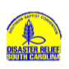
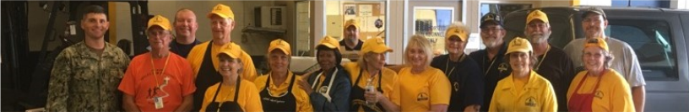
SITUATION REPORT
October 27, 2018

S
SC Disaster Relief - Hurricane Florence Response
- Two Command Post sites each have mud-out units working, along with chaplains, assessors, shower/laundry, feeding, and site management volunteers.
  - North Conway BC- SC units and a feeding team from Minnesota
  - Living Water BC, Longs- being run by Texas (SBTC) DR using SC and TX units. Starting today, the Incident Commander at this site is Darrell McCain, DR Director from Hawaii.
  - The Cheraw and Dillon sites are now closed.
- States that have sent multiple teams to help: Mississippi, Georgia, Texas (SBTC)
- States that have sent a team or an Incident Commander (IC): Alabama, Tennessee, Hawaii, Minnesota/Wisconsin

Total Hurricane Florence Response in SC, reported as of 10/23/18:

Professions of Faith 32
Gospel Presentations 253
Ministry/Chaplaincy Contacts 1,895
Volunteer Days 4,481
Total Meals 90,503
Assessments 481
Chainsaw jobs 72
Complete Flood Clean-up jobs 398
Tear-outs 71
Pressure Wash 9
Mold Remediation 263
Temporary roofing (tarps) 33
Showers 4,309
Laundry Loads 1,919
Hurricane Michael Response
- A team of SC feeding volunteers returned yesterday from serving with a Florida mobile kitchen in Panama City, FL, helping to prepare 6,000-8,000 meals per day.
- An SC shower/laundry unit is in Colquitt, Georgia to support volunteers working in the area.
- Four SC chainsaw units will serve next week in Blakely, Georgia and one other the following week. The first of these units is on the road today (10/27).

