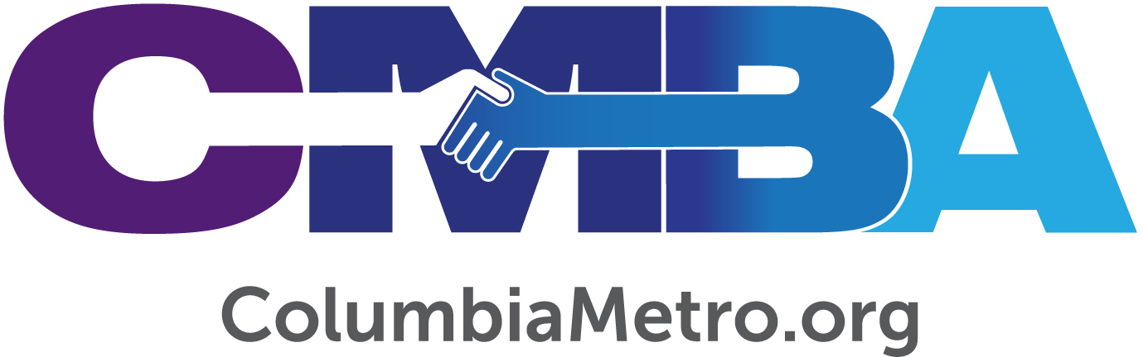

Beulah Baptist on Mission - Drilling Fresh Water in Remote Villages, Building Local Relationships

Beulah Baptist Church members love their neighbors, near and far. The church is active in a variety of local missions, international mission partnerships and one very unique ministry introduced by Pastor Cameron DeBrew. For Christmas 2015, DeBrew’s family agreed to use the money they would have spent on gifts to each other and instead send it to a ministry that drills wells in remote areas of Africa without access to fresh water.

“When a well goes into a village there is an agreement that permission must be given to share the gospel when the drilling team is there. As a well is drilled it brings fresh water, and then the Living Water of the gospel is also shared,” says DeBrew, who is celebrating his 27th year on church staff.

The following year DeBrew shared about his family’s experience of purchasing the well with Beulah Baptist church members, expecting there might be some interest. Several members purchased wells individually that year and, combined with additional giving in the years since, DeBrew estimates the church has given about $25,000 to support the ministry to date.

“We’re not a large wealthy church. For whatever reason this ministry has caught on with our people,” he says.

DeBrew has developed a relationship with the ministry, recently renamed Set Free Alliance, headquartered in Greer, South Carolina. Set Free Alliance is active in other needs-based efforts throughout West Africa and India, including rescuing young people from various forms of slavery and partnering to plant churches. Alliance Development Coordinator Afton Schipper says partnering with churches like Beulah Baptist can provide a new perspective for individuals as they learn about the needs of those around the world.

“We desire for our partners to know God on a larger level and to hear of how He is working in other cultures and in places where we may have never been. It is an honor to get to share stories of lives changed for eternity and to show the impact that our US partners can have. When our partners understand the importance and necessity of their involvement, we know that the Lord is working. We are so grateful for partners like Cameron who humbly accept God’s call to be a part of His work around the world,” Schipper says.

Set Free Alliance secures a local pastor to accompany well drilling teams when they arrive in a village to work. As a result, a network of these local pastors has developed and one of those pastors will be in the United States this fall. DeBrew has worked with Set Free Alliance to allow the pastor to share about the ministry opportunity in the Columbia area.

“This has been such a beneficial ministry to us as a congregation as we’ve prayed and raised money to give and see God work through it. I want to put this kind of ministry opportunity in front of as many pastors as possible,” DeBrew says.

The free one-day event is slated for Tuesday, September 24th at State Street Baptist Church in Cayce. The presentation starts at noon and will include a free lunch.

“Set Free’s Columbia Pastor’s Lunch is an opportunity for local pastors to hear about the amazing work that the Lord is doing first-hand. Our special guest Praveen Chakravarthy works with a team of thousands of partner pastors across India to bring hope and restoration to children and families. Specifically, we minister to the impoverished, forgotten and exploited through the drilling of wells, hosting of medical clinics and caring of children rescued from the slave industry. By meeting physical needs, we are able to point hearts to Christ. We want to invite all local pastors to meet Praveen and hear his incredible stories of the Lord at work,” adds Schipper.

In addition to providing clean water internationally, Beulah Baptist members also partner with Southern Baptist missionaries serving around the world. The church has sent short term mission teams to several countries, and actively supports international students studying at the University of South Carolina’s Columbia campus.

“We enjoy hosting the Baptist Collegiate Ministry international luncheon twice a year. Almost all of the ministries we are involved in began because one of our church members had a heart for it and worked to see it come into existence.” DeBrew explains.

Beulah Baptist operates a community emergency food pantry every week, and clothes closet twice a month. A group from the church also helps feed the homeless once a month at Transitions Homeless Center. The church has been intentional with opportunities to show love and support to the immediate community by hosting a teacher appreciation breakfast at the local elementary school and they feed the Lower Richland High School football team before home and away games each fall, during which church members or pastors share a gospel presentation and word of encouragement from scripture to the players and coaches. Beulah Baptist partners with the Richland County Library by offering its facility for kindergarten classes and tutoring, and other area churches have followed suit.

“I think it’s the call of Scripture for us to minister locally and internationally. I remind our church that USC has 102 nations represented, so God has literally brought the world to our backdoor. It’s important because it reminds us of our call as believers to go into all the world in Jesus’ name and through the power of the Holy Spirit share the good news of the gospel. We try to model that in all of the ministries we do,” DeBrew says.

Founded in 1806, Beulah Baptist has a long history in its rural community. Several years ago, DeBrew says it occurred to him that he didn’t know other nearby pastors or their churches, so he reached out to begin building relationships across denominational lines.

“It’s been an intentional act of trying to get together and get to know each other to broaden our network. A lot of that joint partnership involves coming together as pastors and church leaders to pray for each other and for our communities. We are trying to be a community of faith with all Lower Richland area churches,” he says.

DeBrew calls the experience “eye-opening,” and one that has helped him love the greater community even more. As a result of these new relationships he says the leaders educate and share from their frame of references. Plus, now they can recognize each other at the grocery store.

“We’ve begun to do things together. When the church shootings happened, some of the churches organized a safety planning event led by the Sheriff’s Department for churches in the Richland County area. As our church goes into schools or ministry areas, if I think a brother pastor can meet a need better than my church can, then I have that relationship to call him up and represent our community as a body of faith instead of just individual churches,” DeBrew says.

And that’s key to Beulah Baptist’s story - it sees itself as a member of the greater body of believers while being proactive to meet needs.

“I believe the Lord opens doors. A church can do something simple like a back-to-school event to begin reaching into the community. Churches have personalities and gifts to do certain things and, as each one listens to the Lord and follows His leadership, there are many things to become involved in. We want to be good stewards and I think the Lord has given us a faithful congregation of stewards to serve this community and His kingdom,” DeBrew says.

For more information about the September 24th event or to register, contact DeBrew at debrewcameron@msn.com. For more online information about Set Free Alliance and its ministries, visit www.setfreealliance.org.

