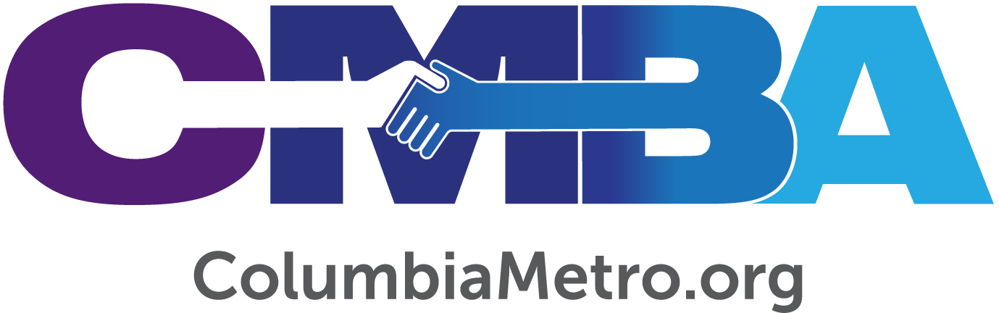

“Love Cola” Invites Churches to Love, Serve Their Communities

In October, Midlands churches – including the Columbia Metro Baptist Association family of churches -- will partner together through service and ministry projects with the sole purpose of showing the love of Jesus to their communities. Under the name Love Cola, volunteers will take to the streets to engage and serve through pre-arranged ministries on Saturday, October 5th, and then gather for a city-wide worship and celebration service at Segra Park – home of the Columbia Fireflies -- on Sunday, October 6th at 6 p.m. As of mid-August, 19 churches have committed to participate in the first Love Cola, which began as an annual community service day through Shandon Baptist Church.

“Several years ago Shandon began doing service projects in the city. Last year more than 600 members served with partners around the Midlands. Our pastor, George Wright, wanted to rally churches of all denominations to be united with the Great Commandment and so the conversations started with staff and other pastors in the city. It became more formal over time, turning it from a dream to a reality,” says David Taylor, missions minister at Shandon Baptist.

For his part, Wright says Love Cola is designed to be a tangible expression of the love of God for the city of Columbia.

“We want Columbia to know that God’s love has been made available to the city that we call home. There is much that is said about the differences and disagreements between churches today. We realize that churches do not agree on everything, but one thing we can absolutely stand together on is the Great Commandment of Jesus in Matthew 22: 34-40. The way that we show we truly love God is to love our neighbor. We are praying that churches will come together to show our great city a living picture of God’s love,” Wright says.

George Bullard, Executive Director of the Columbia Metro Baptist Association, is in full support of this effort to impact our community and urges our family of congregations to consider participation to show the unconditional love of God to the Midlands community. “This effort is consistent with Our One Priority as an association which seeks to start and strengthen congregations to serve as vital and vibrant missional communities. Love Cola carries out the spirit and intent of Operation Inasmuch which we launched in Columbia last year and Shandon was one of the churches whose own efforts took place on one of the two days of our 2018 effort.”

As partnering churches from across the area have committed to participate, the team at Shandon Baptist is tackling the details of communication, linking ministry opportunities and assembling teams that already have service projects lined up. Taylor calls his role as “managing the ground game,” which also includes empowering volunteer groups and churches to recruit and choose projects that are purposeful to relationships in the community and might be ways to launch continued ministry.

“We invite any and all Christian churches to join us. Churches are not asked to mobilize an entire congregation either - if you have a small group that wants to participate, whether it’s 5 or 50, come and do it. Start with a pilot team that wants to do it this year and let them get their feet wet so that next year they can knock it out of park,” Taylor explains.

The process to join the Love Cola movement is simple. Churches can register online at www.LoveCola.org and will receive a follow up contact. At this stage it’s best if churches that are signing up already have an idea of the project they’d like to do, but the website does have a list of organizations that have requested volunteer support on October 5th to give some ideas.

“We can handle as many people as want to serve. As late as we are in the game, if you want to do something on that day, or that week, we’d ask that you go ahead and be proactive and do something you know how to do already. Then we can help with the logistics,” Taylor says.

Shandon Baptist estimates that there will be ministry happening in about 50 locations across the Midlands through Love Cola. Organizations receiving services include the Columbia Fire Department, DAYBREAK Ministries, Lutheran Services Carolina and Home Works of America. Taylor says the most effective ministries should be church-driven and reflect the idea of doing something special with a neighbor.

“The church across from a community retirement center can go love them for the day. If a church is next to a strip mall that collects a lot of litter, let the business owners know you’re there and go clean up the lot for them. Discuss what can we, as a church, do to show love to our neighbors or the city today? It’s really that simple,” he says.

Cathy Locklear, community impact ministry mobilizer with the Columbia Metro Association, is also ready to support and assist churches as they participate in Love Cola and serve as vibrant missional communities. According to Locklear, the experience will allow church members to connect with their neighbors while strengthening a congregation as it works together.

“Missions is a biblical mandate. This opportunity of participating in an organized area mission event shows the heart of the church to reach out to the community. By participating in Love Cola individual churches can communicate, by demonstration, the love of Christ for all,” she says.

Partnership is a big component of Love Cola, and congregations as far away as Chapin and Lexington will be ministering locally and joining in the corporate worship the following day. Taylor says teams from Shandon will partner with a variety of organizations that day but will focus on those located near the church.

“We are asking any church in the Midlands to just love their neighbors and that biblical definition is broad – those who are near us, those who are like us and those unlike us. These ministries and activities will reflect all of that,” Taylor says.

For more online information or to sign up for Love Cola, visit www.LoveCola.org.

