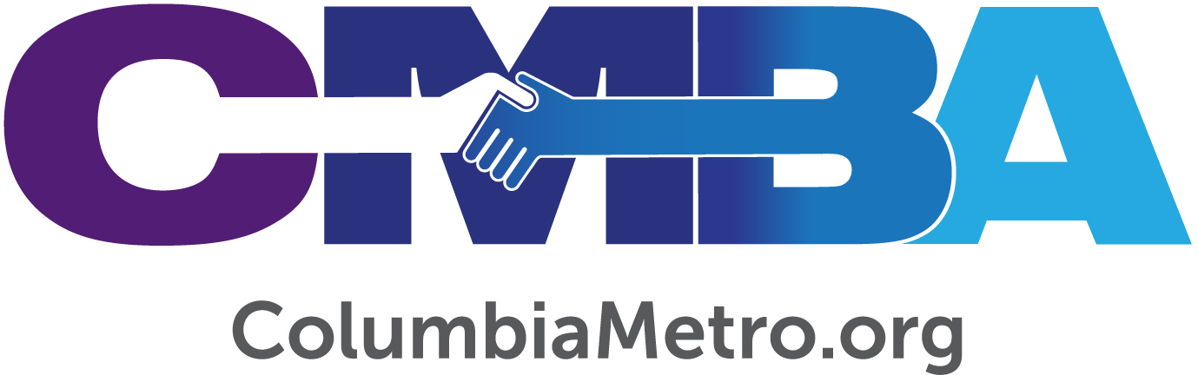

David Waganer Seeks to Empower Congregations

The Columbia Metro Baptist Association (CMBA) welcomes David Waganer, an independent contract worker who began his responsibilities as an Empowering Congregations Ministry Mobilizer in April. In this role David is charged with helping churches navigate the areas of stewardship education and interim congregational issues, including initial committee organization, receiving and evaluating resumes and the search process, ministry ordination and working through a church’s opportunities during conflict. His experience assisting churches in transition has given David an ability to help simplify many situations churches face during these times.

“I’ve seen it all, over and over again. I know the big picture before a church starts to tell me. I don’t have all the answers, but I like to help as much as I can behind the scenes. I also know what it means to move from one church ministry position to another and how to help a church prepare for that new leader,” he says.

David was born in Fort Worth, Texas, and came to know Jesus as his personal savior as a child. A graduate of Oklahoma Baptist University, David also holds two master’s degrees from New Orleans Baptist Theological Seminary and earned a Doctor of Ministry from Midwestern Baptist Theological Seminary. He has served for more than 30 years in denominational work through the local church as well as in various positions at the state level with the South Carolina, Oklahoma and Missouri Baptist Conventions. Of special note, David has served as a transitional or interim pastor with 20 different churches over the years which uniquely prepares him to assist CMBA churches.

He and his wife Karen have two adult children and six grandchildren, of whom he says he has the “great pleasure of seeing grow in their relationship with Jesus to become the individuals God created them to be. We look forward to spoiling each of them in the years ahead.”

In his free time David enjoys gardening, traveling and golfing which, he admits, also gives him access to meeting new people. He sees regular time spent on the golf course with a group of about 30 men as an opportunity to make a difference in their lives. For the last five years David has served as a volunteer associate chaplain at Lexington Medical Center, which has allowed him to see the power of building fast relationships with folks in difficult circumstances.

“God has prepared us for where we are in life. When I walk into a hospital room and a man is doubting his salvation, I can help him walk back through his experiences so that the Lord can speak to him. When I’m on assignment I typically go in to about 30 rooms and I ask God to allow me to have two significant conversations. Over the years He’s given me many more than that. That work is just as much ministry as helping Columbia Metro with these needs. I’ll go beyond the call of what I should do in order to help,” he explains.

David says the skills and experiences he has had working in full time ministry have prepared him for his role as Empowering Congregations Ministry Mobilizer. Through his work in stewardship, David helped to create resources for Southern Baptist churches to use. Now, he can help CMBA churches use those same resources while continuing in his passion for stewardship education.

He anticipates being able to quickly provide practical assistance to churches during conflict, positioning them to pursue healthy progress toward resolution that starts with improved communication. One new responsibility that he is excited to focus on is in the area of ministerial ordinations.

“I have dealt with ordinations but haven’t really considered the different possibilities of ways to do it. So, I am spending some time working on that. I want for it to be a creative and meaningful experience for all involved, so I’m looking at questions to ask in the ordination process and what background work needs to be done in order to present the best candidate that is qualified biblically and in all other ways,” he says.

David is also excited to connect with young pastors and build relationships with local church staff. He recognizes God’s hand at work throughout his own career and how those different lessons learned along the way link to opportunities today. He looks forward to helping to make those same connections in the lives of young pastors.

“I graduated from college with a double major. I didn’t do much with my drama education until I worked in stewardship, where I saw that I could use my drama skills in ministry. I didn’t go to school to study stewardship, yet it ended up being a calling and a heart thing for me. Now I see everything as stewardship – life, choices, time, it’s in everything. As I look at my life, I’ve seen the pieces come together and how God uses them all,” David says.

After such a long career in church work it might come as a surprise to some to learn that one of the things David is most excited about related to his new role with CMBA is the opportunity to be an active member of a local church.

“After working with so many churches for nearly 30 years, I’ve never ‘landed’ as a regular church member. I have always been helping a church become healthy, get a new leader and then I leave. As a result, my wife and I haven’t had a real church home. We recently joined Northside Baptist Church in Lexington and are excited about being a part of a life group and getting connected to a local church,” he says.

To reach David for services related to stewardship education, interim or transitional church needs, conflict mediation, and ministerial ordination contact the CMBA office at 803.619.7110.

